Time Series Forecasting with LSTM Network Based Model for ENSO

Cheng Peng, Bin Mu and Shijin Yuan

School of Software Engineering, Tongji University, Shanghai 201804, China

{pengcheng, binmu}@tongji.edu.cn, yuanshijin2003@163.com

Abstract

We applied LSTM networks to study El Niño Southern Oscillation (ENSO) in this paper, which can been viewed as a time series forecasting problem on climate change field. We designed different experiments to testify the effectiveness of prediction models with different time series steps. the result showed that the LSTM networks have the ability to capture the long dependencies between the SST data, then forecast the ENSO phenomenon of 15~16 successfully, which show great potential as the supplement with the conventional prediction models, especially with longer multiple steps forecast ahead.

1 Introduction

The El Niño-Southern Oscillation (ENSO) is an irregularly periodic variation during the eastern equatorial Pacific, which is considered as the dominant mode of interannual climate variability observed globally (Wunsch 1990). ENSO is associated with many climate changes globally (Fraedrich 1994; Wilkinson et al.1999), so a skillful prediction of ENSO is highly desired.

So far, both dynamical and statistical models are applied for forecasting ENSO (Barnston 2012). The dynamical models use physical equations of the ocean and atmosphere to forecast ENSO and the statistical models use mathematical formulations to learn from the observed data to forecast ENSO. However, ENSO is not predicted well enough up to 6 months due to the existence of predictability barrier (Goddard et al., 2001), and the computationally are very expensive while applying those climate models. Those two points remain room for further study for this problem.

Recently, some researchers have attempted to apply machine learning methods for this problem, especially deep learning methods. LSTM networks have been applied to predict sea surface temperature (SST) (Zhang 2017) and tropical cyclones (Li 2017), which are highly related to ENSO phenomenon (Hong 2001; Catto 2012). A hybrid model with ANN and ARIMA model have also been used to predict ENSO, and the result is slightly better than an ensemble prediction model (Nooteboom 2018). Those preliminary results show great potential with Long Short-Term Memory (LSTM) (Hochreiter 1997) networks for studying ENSO case, which will be discussed further in this paper.

The structure of this paper as follow: Section 2 formalizes the ENSO forecasting problem, which we transferred as a time series problem here. In Section 3, we discussed the data and applied model details. The experiment result and detailed parameters setting are reported in Section 4. The paper concludes with a summary and discussion in Section 5.

2 Problem Formulation

To quantify ENSO, there exist several indices to monitor the tropical Pacific, all of which are based on SST anomalies averaged across a given region (Figure 1). Among those different NINO indices, NINO3.4 index is the average SST anomaly in the region bounded by 5°N to 5°S, from 170°W to 120°W. This region has large variability on ENSO time scales, and is close to the region where changes in local SST are important for shifting the large region of rainfall typically located in the far western Pacific. NINO3.4 index is one of the most commonly used indices to define ENSO phenomenon, we use NINO3.4 index as the predictand in this paper. The prediction of ENSO can be regarded as a problem of predict NINO3.4 index with different time steps ahead.

Concretely, we list the observed NINO3.4 indices as a time series sequence as input (training data) to train our model, then use the model to predict the next several monthly NINO3.4 indices with different predict steps, and then compare the result with reality and result of climates models. It is worth mentioning that the length of prediction is critical here, as a prediction with lead times up to 1 year, is high desired (Nooteboom 2018).

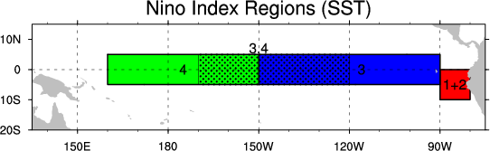

Figure 1: Different Nino index Regions

3 Data and Model

Dataset Description

We use the National Oceanic and Atmospheric Admin- istration’s (NOAA’s) climate time series data for our experiment, which including the longest timescale monthly NINO3.4 index data (from 1870 to May 2018) to best of our knowledge, and it’s periodically updated. the data is available on this website: <https://www.esrl.noaa.gov/psd/gcos_wgsp/Timeseries/Nino34/>.

From pure data preprocessing perspective, it seems wiser to investigate different data preparation techniques to rescale the data (normalization) and make the data stationary, However, the data of NINO3.4 index seems born with those well-processed data properties – The mean is close to 0; the distribution is near Gaussian; not white noise, and from the result of our experiment, the improvement of preprocessing is not obvious.

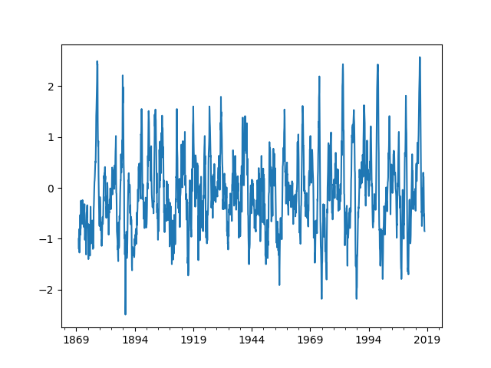

Figure 2: Line plot of NINO34 Index from 1870 to 2017

It should be noted that, some works have been done for the same forecasting problem. Most of them focus on figuring out the best parameters combination for a better result, and some of them use the climate network theory (Albert 2002) to try to involving much data as possible. However, the potential of the prediction model itself is rarely discussed, we have only use limited size of data in this paper, and concentrate on improving the performance of model.

MIMO Time Series Forecasting

The task of multiple steps is to predict two or more steps ahead using single-output or multiple-output strategy (Taieb 2012), and the multiple-output strategy is called multiple-input multiple-output (MIMO) time series forecasting, it models time series data as a multiple-input multiple-output function.

Based on the previous observed sequence X = {$φ^{t-n-1},φ^{t-n-2},…,φ^{t}$} as the input, predict the future Y = {$φ^{t+1},φ^{t+2},…,φ^{t+m}$}, *n* and *m* stand for the length of input and output respectively.

Long Short-Term Memory

LSTM is a special kind of recurrent neural network (RNN), which can capture the temporal relationship among time series data. Compare with conventional RNN, LSTM addressed the vanishing and exploding gradients problem during training process, then solving the long-range dependencies among time series data, the whole structure of a LSTM cell is showed in Figure 3, and the whole computation process can be defined as a series of equations (Graves 2013) showed in (1):

$$i_{t}= σ\left(W^{i}H+ b^{i}\right) \\ { f}_{t}= σ\left(W^{f}H+ b^{f}\right) \\ { o}_{t}= σ\left(W^{o}H+ b^{o}\right)$$

$$c_{t}= tanh\left(W^{c}H+ b^{c}\right) \\ { m}_{t}= f_{t}⊙m_{t-1}+i_{t}⊙c_{t}$$

${ h}_{t}= tanh\left(o_{t}⊙m_{t}\right)$ (1)

where $σ$ is the activation function (here is sigmoid function), $W^{i}$, $W^{o}$, $W^{f}$ and $W^{c}$ represent the recurrent weight metrics, $b^{i}$, $b^{o}$, $b^{f}$, and $b^{c}$ are the bias terms respectively. *H* represents a concatenation of the new input $x_{t}$ and the previous hidden vector $h_{t-1}$.

The key of LSTM is the cell state, which plays the role of control the information added or removed, carefully regulated by structures called gates. There exist 3 kind of gates in (1): *i*, *f* and *o* represent *input gate*, *forget gate* and *output gate.* The input gate decides how much information enters the current cell. The forget gate decides how much information be forgotten(removed) from the previous memory vector $m_{t-1}$. The output gate decides what information will be output from the current cell.

There have many works on exploring the structure of LSTM (Yao 2015, Greff 2017), but not go deep into a specified task. We need develop a model based on convention LSTM to fit our ENSO forecasting task.

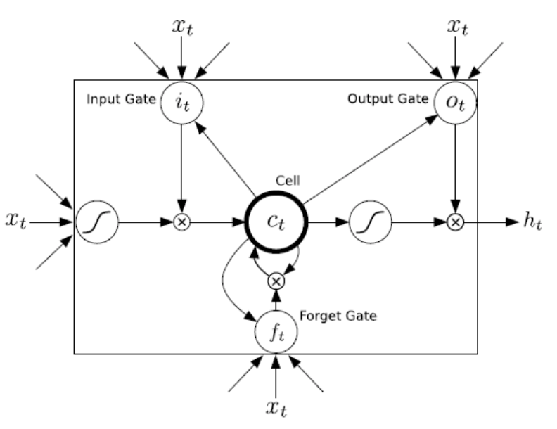

Figure 3: LSTM (Hochreiter 1997)

LSTM Based Model

From the data processing perspective, a time series data is not suitable as dataset for machine learning inborn. Before the network model process, we must try the prepare data process first, this process including 3 subtasks: data split, preprocessing and sequence generate (detailed parameters setting will be discussed in Section 4).

After getting the processed dataset, we put those data to LSTMs based model. In general, to construct a fully end-to-end model, we need combine the LSTM layers and Fully-Connected (FC) layers to form a LSTM block, the output of LSTM layer is a vector of the state of the last time step, then the FC layer is used for data abstraction and reduce dimensionality, then the output of network model is a series data that stand for the next status, for ENSO, means the NINO3.4 index of next several months. The whole model structure showed in Figure 4.

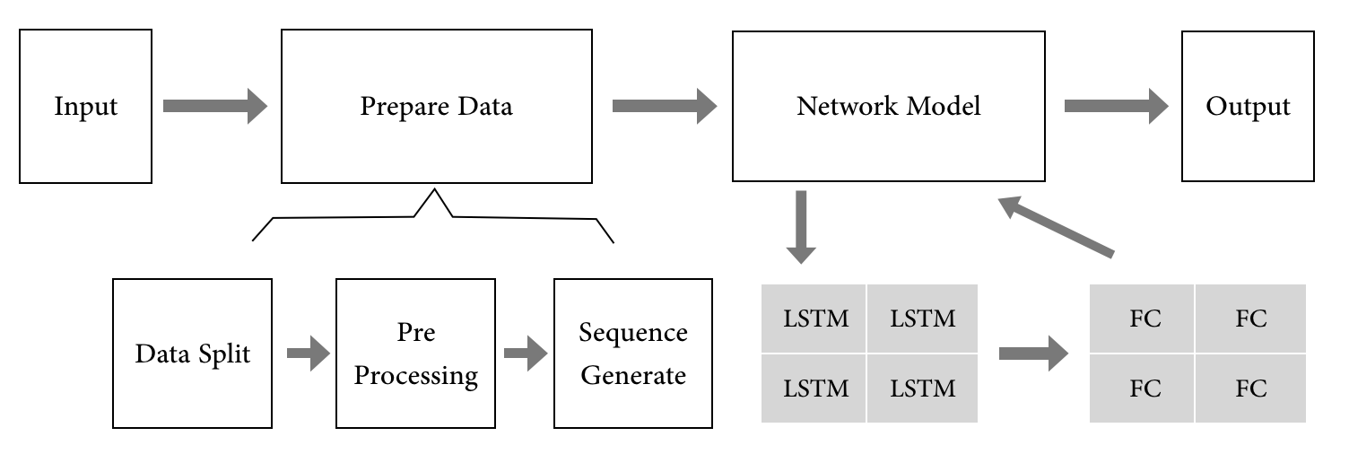

Figure 4: Model Structure

4 Experiment

s

Compare with Convention Neural Networks

Detailed

Compare with Climate Models

This is example text. It is 10 point Times New Roman. This is example text. It is 10 point Times New Roman.

Prediction of ENSO during 2015~2016

This is example text. It is 10 point Times New Roman. This is example text. It is 10 point Times New Roman.

5 Conclusion

Use of the section heading style is required.  
Applied LSTM for ENSO case and compare the result with classical models, the result show great potential for this problem.

Works todo :

1.more complex data setting (considering the inner Dynamics mechanism) ;  
2. Single is not enough to cover all ENSO information, grid dataset is a optional;

References

Wunsch, C. 1990. El Nino, La Nina, and the Southern Oscillation. *Science* 248(4957), 904-906.

Barnston, A. G., Tippett, M. K., L'Heureux, M. L., Li, S., & DeWitt, D. G. 2012. Skill of real-time seasonal ENSO model predictions during 2002–11: Is our capability increasing?. *Bulletin of the American Meteorological Society* 93(5), 631-651.

Zhang, Q., Wang, H., Dong, J., Zhong, G., & Sun, X. 2017. Prediction of sea surface temperature using long short-term memory. *IEEE Geoscience and Remote Sensing Letters* 14(10), 1745-1749.

Nooteboom, P. D., Feng, Q. Y., López, C., Hernández-García, E., & Dijkstra, H. A. 2018. Using Network Theory and Machine Learning to predict El Niño. *arXiv preprint arXiv*:1803.10076.

Rayner, N. A., Parker, D. E., Horton, E. B., Folland, C. K., Alexander, L. V., Rowell, D. P., ... & Kaplan, A. 2003. Global analyses of sea surface temperature, sea ice, and night marine air temperature since the late nineteenth century. *Journal of Geophysical Research: Atmospheres* 108(D14).

Goddard, L., Mason, S. J., Zebiak, S. E., Ropelewski, C. F., Basher, R., & Cane, M. A. 2001. Current approaches to seasonal to interannual climate predictions. *International Journal of Climatology* 21(9), 1111-1152.

Li, Y., Yang, R., Yang, C., Yu, M., Hu, F., & Jiang, Y. 2017. Leveraging LSTM for rapid intensifications prediction of tropical cyclones*. ISPRS Annals of Photogrammetry, Remote Sensing & Spatial Information Sciences*, 4.

Hong, C. H., Cho, K. D., & Kim, H. J. 2001. The relationship between ENSO events and sea surface temperature in the East (Japan) Sea. *Progress in oceanography* 49(1-4), 21-40.

Catto, J. L., Nicholls, N., & Jakob, C. 2012. North Australian sea surface temperatures and the El Niño–Southern Oscillation in observations and models*. Journal of Climate* 25(14), 5011-5029.

Dijkstra, H. A. 2006. The ENSO phenomenon: theory and mechanisms. *Advances in Geosciences* 6, 3-15.

Trenberth, Kevin & National Center for Atmospheric Research Staff (Eds). Last modified 02 Feb 2016. "*The Climate Data Guide: Nino SST Indices (Nino 1+2, 3, 3.4, 4; ONI and TNI)*." Retrieved from <https://climatedataguide.ucar.edu/climate-data/nino-sst-indices-nino-12-3-34-4-oni-and-tni>.

Albert, R., & Barabási, A. L. 2002. *Statistical mechanics of complex networks. Reviews of modern physics* 74(1), 47.

Taieb, S. B., Bontempi, G., Atiya, A. F., & Sorjamaa, A. 2012. A review and comparison of strategies for multi-step ahead time series forecasting based on the NN5 forecasting competition. *Expert systems with applications* 39(8), 7067-7083.

Hochreiter, S., & Schmidhuber, J. 1997. Long short-term memory. *Neural computation* 9(8), 1735-1780.

Graves, A. 2013. Generating sequences with recurrent neural networks. *arXiv preprint arXiv:* 1308.0850.

Yao, K., Cohn, T., Vylomova, K., Duh, K., & Dyer, C. 2015. Depth-gated recurrent neural networks. *arXiv preprint. arXiv preprint arXiv:*1508.03790, 9.

Greff, K., Srivastava, R. K., Koutník, J., Steunebrink, B. R., & Schmidhuber, J. 2017. LSTM: A search space odyssey. *IEEE transactions on neural networks and learning systems* 28(10), 2222-2232.

Abstract

This is an example abstract. It goes here in 9 point Times New Roman type. Use of the Abstract Text style is required.

Deleting this Example of a Section Heading will Remove the Copyright Line*[1]*

There are invisible characters after the word Line in the heading above. If you delete them, the copyright line will disappear. The AAAI copyright notice is required. This is example text. It is 10 point Times New Roman. The first sentence after the heading begins without a paragraph indent. Use of the text style (without alteration) is required.

This is example text. The second paragraph is indented 10 points, with no extra space between lines. The text is 10 point Times New Roman.

This Example Subsection Heading   
This Style Sheet Must Be Applied to All Section Headings

The text below a second-level heading begins without indentation. Use of the subsection heading style is required.

This is the second paragraph. It in formatted with the Text-indent style. Use of the Text-Indent style is required.

This Is a Subsubsection Heading. Use of This Style Sheet Is Required for all subsubsections.

This is example text. It is 10 point Times New Roman. This is example text. It is 10 point Times New Roman.

This is example indented text. It is 10 point Times New Roman. This is example indented text. It is 10 point Times New Roman. This is example indented text. It is 10 point Times New Roman. This is example indented text. It is 10 point Times New Roman.

This is an example of an extract or quotation. Note the indent on both sides. Quotation marks are not neces­sary if you offset the text in a block like this, and properly identify and cite the quotation in the text.

This Is an Example of a Figure Caption. Use of the figure caption style is required.

This Is a Section Heading   
This Style Sheet Must Be Applied   
to All Section Headings

Use of the section heading style is required.

Margins

Papers **must** be printed in two-column format on 8-1⁄2 x 11 inch paper. The margins if you use 8-1/2 x 11 inch paper must be **exactly** as follows:

• Top margin: 3⁄4 of an inch

• Left margin: 3⁄4 inch

• Right margin: 3⁄4 inch

• Bottom margin: 1-1⁄4 inches

**Be certain that the margins apply to all pages in your document, not just the first section.** The actual image size for your paper (minus margins) is 7x 9 inches (17.78 x 22.86 cm). Papers that deviate from these measurements will not be published.

Style Sheet Use and Alterations

You are required to use the style sheets embedded in this document without alteration.

Fonts

All fonts must be embedded for your paper to be published. No exceptions.

Citation Style and Reference Style

All AAAI papers must use author year citations in the text (Engelmore and Morgan 1986). Numbered references may not be used. The references must be formatted using the exact references style shown in the next paragraph. Citations must be placed in alphabetical order. Lines must be justified. References may not be numbered. No indent is allowed. The style sheet will automatically add the proper amount of space between entries; no additional space should be added.

References

Clancey, W. J. 1984. Classification Problem Solving. In *Proceedings of the Fourth National Conference on Artifi­cial Intelligence,* 49-54. Menlo Park, Calif.: AAAI Press.

Engelmore, R., and Morgan, A. eds. 1986. *Blackboard Sys­tems.* Reading, Mass.: Addison-Wesley.

Hasling, D. W.; Clancey, W. J.; and Rennels, G. R. 1983. Strategic Explanations in Consultation. *The International Journal of Man-Machine Studies* 20(1): 3–19.

Rice, J. 1986. Poligon: A System for Parallel Problem Solving, Technical Report, KSL-86-19, Department of Computer Science, Stanford University, Stanford, CA.

Robinson, A. L. 1980a. New Ways to Make Microcircuits Smaller. *Science* 208:1019-1026.

1. Copyright © 2019, Association for the Advancement of Artificial Intelligence (www.aaai.org). All rights reserved.